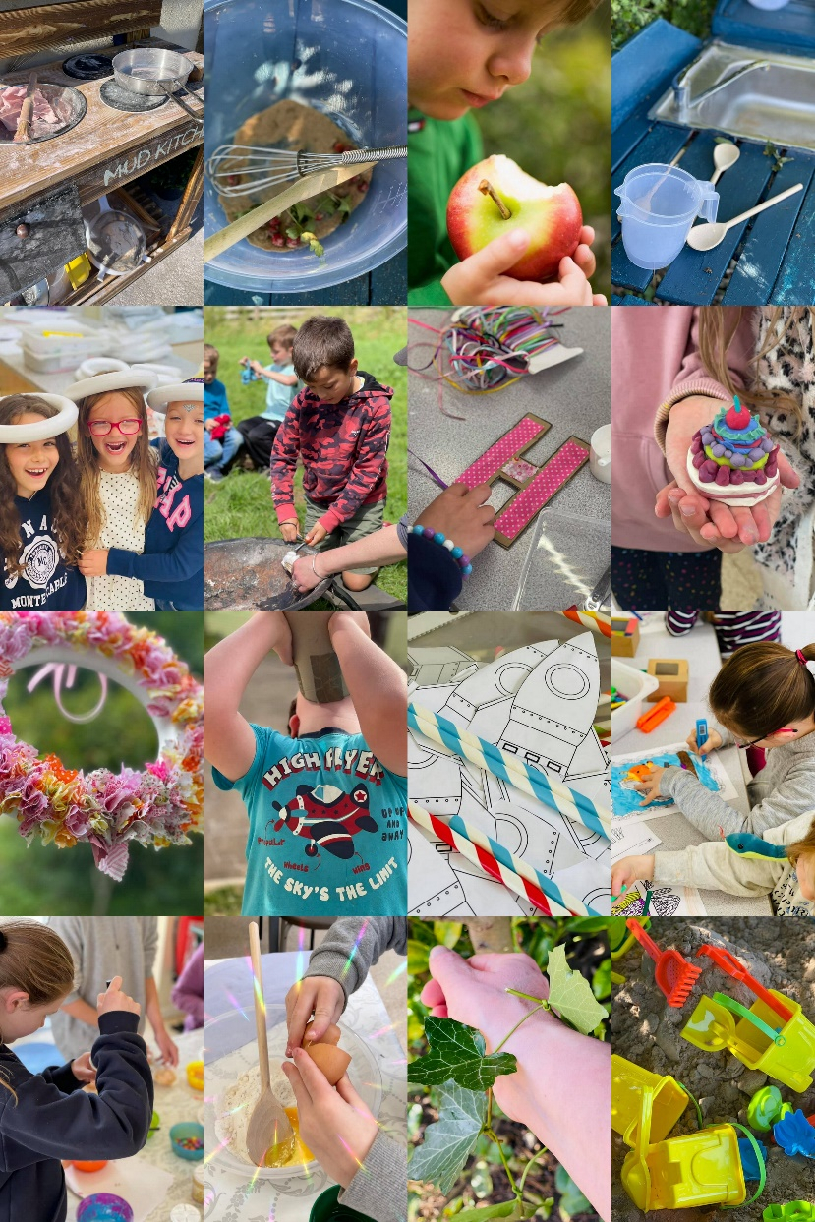

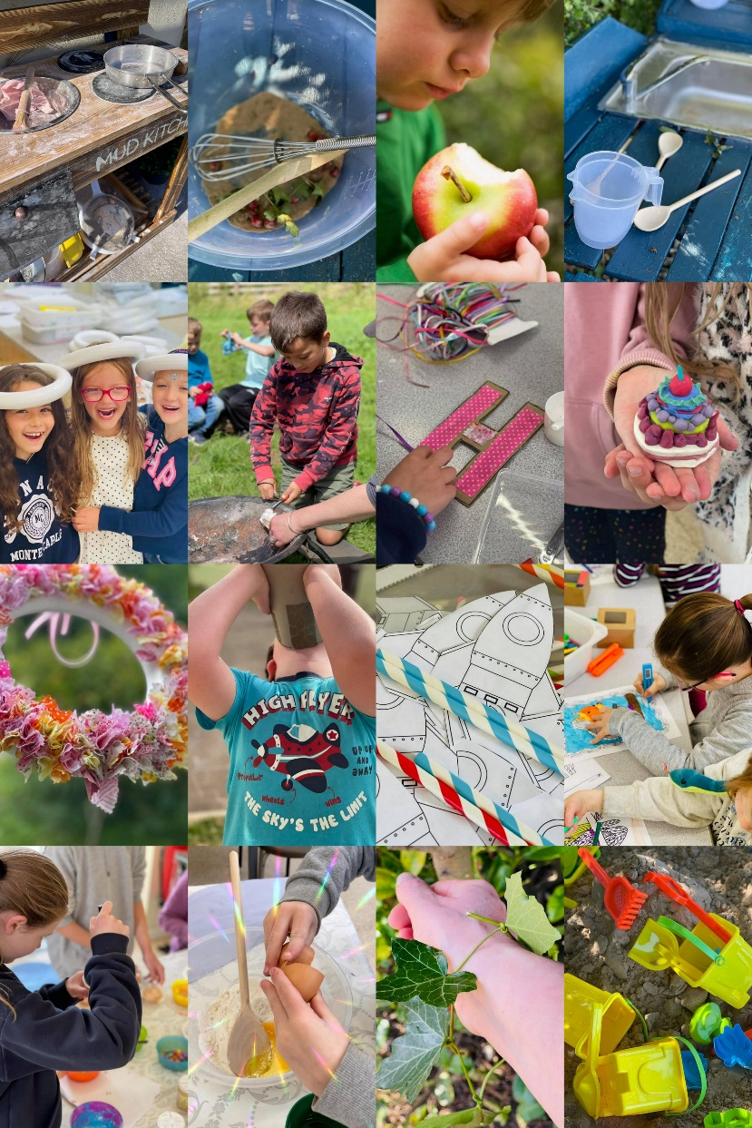
PROSPECTUS

HIGH FLYERS
Welcome aboard everyone, to High Flyers out of school club!
We do hope you find this useful – we have a Parent Handbook, available on our website for more information but please contact us if you have any questions or requests.
Find us on Instagram, Facebook and on our website. Just search High Flyers Oxford Limited or use www.highflyers.org.uk
Taking flight
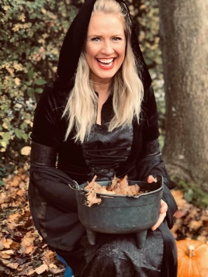
High Flyers was founded by Alison Ighani, shortly after moving to Adderbury in 2012. Using her experience in aviation, events and business High Flyers was born. It’s aim, to fill the need for wrap around childcare within the community, centred at the local primary school which was the inspiration. The business has now grown to help support parents in neighbouring villages.

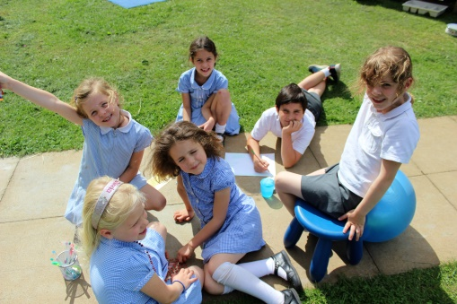
Our vision
Here at High Flyers Oxford, we stimulate and inspire young minds through play, new experiences and having fun together, with children at the heart of everything we do. Our OFSTED registered company has been providing high quality breakfast, after-school, and holiday clubs for nearly 10 years within Oxfordshire which carefully combine the freedom of unstructured play, with a balance of planned activities, for reception to year 6 children.
High Flyers Oxford offers a no-guilt alternative to childcare, making parents lives simpler whilst ensuring their children have a fun and well-rounded experience in a club where they feel they belong. We encourage teamwork, kindness and creative thinking to help all our children become confident and happy ‘High Flyers’, supported by a team of dedicated and caring staff putting the children first in everything we do

Sessions available
Morning Breakfast 8.00am until School
Half session ‘After School’ until 4.30pm
Full session ‘After School’ until 5.30pm/6.00pm
Registration and Bookings
If you are interested in your child attending High Flyers please complete the online registration https://highflyersoxfordlimited.schoolipal.co.uk
We pride ourselves on being as flexible as possible to accommodate your childcare needs. Once your child is registered you can book in advance and book on the day.
If you need to book an ‘on the day’ session, please call school and let your child’s teacher know and we will do the rest.
If your child is unable to attend, please let us know through the message section on our booking system or message us directly.
When paying online we accept card payments or child care vouchers. If paying On Line: High Flyers Oxford Limited, Barclays Bank PLC SC 20 03 84 A/N 83967069
Please use your child’s name as a reference for any payments, more information can be found in the ‘Parent Handbook’.

Arrival and Departure
Our Before and After School Clubs are situated within the school. The great advantage of this is that the children are in a familiar and safe environment and can easily transition from club to class and vice versa.
The children will be escorted to or from their respective classes by a member of staff at the start/end of the school day. We will be able to collect children from other after school clubs or activities that are held on school site. Please let us know if your child will be attending one of these prior to attending High Flyers.

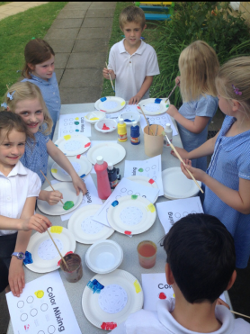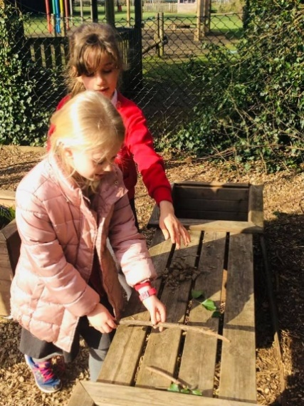

Arrival and Departure cont’
Please deliver your child to the door when dropping them off at breakfast and ensure that you sign your child in/out.
When a parent/carer or other adult identified on the registration form is unable to collect their child, we use a ‘secure word’ password system that you can add online.
The children must be collected by 6.00pm. Please call us if you think you will be late and a solution can be reached together. A charge of £10.00 charged if parents/carers are late.
If your child is not collected at the agreed time and the parent/carer has not advised the club of any delay, we will phone the emergency numbers given on the registration form in order to ensure your child is collected safely.

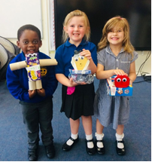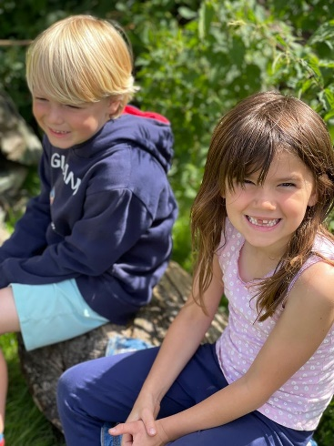

Play
We believe High Flyers is magical for all children due to our delight in play. This is what children do best!
Seeing the children play freely, giggling, using their imagination and having the freedom to do so, is what inspires us. All staff are trained and mentored in how to facilitate and extend play and all opportunities are made the most of!
If you are looking for ideas to do at home please ask a member of staff, we would love to share some ideas with you or direct you to useful websites for ideas.

Donations
We are always looking to top up the supplies we have for the children!
Please feel free to donate any old toys, Lego, dolls, dressing up, DVD’s or anything really.
We also would love donations of loose parts! These are things/ everyday items that are not necessary toys but items a child using the imagination can have lots of fun with. These might include recycling boxes and pots, blankets, shells, tyres, household items, pots and pans, material, boxes, old mobile phones or old keyboards.

Food and Drink
On arrival all children will be offered fruit or snack and a drink, but on occasions we do have treats too! We encourage children to drink water but we have other alternatives, which they can help themselves to any time during the session.
A light tea is served around 4.30pm. We provide a variety of healthy foods for your child. These include pasta, sandwiches and wraps, along with fruit, vegetables and salad.
We encourage the children to help with meals times to make them more independent and learn new life skills. We do insist on exceptional table manners.
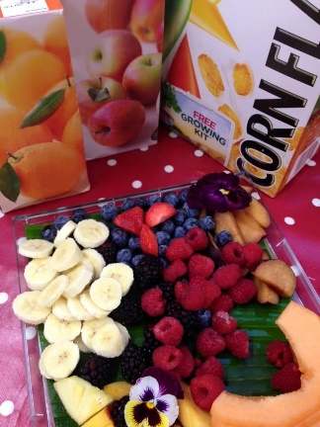
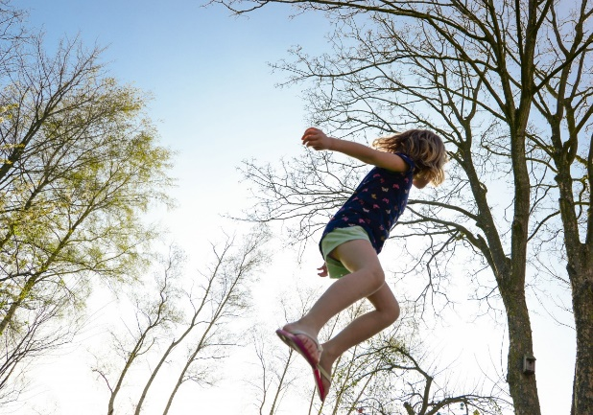
We are a No Nuts school so have no items with sesame or peanuts. We ask you not to bring food to High Flyers containing these.

Health and Safety
Health and Safety is paramount at the Club. Safety, security and trust are the fundamentals of happiness which is why we go to great lengths to make sure your child feels safe and secure.
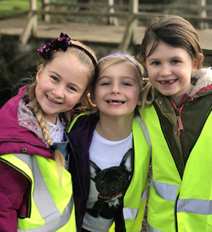
We adhere to a comprehensive range of policies that are reviewed annually. Regular risk assessments are conducted to ensure that the children and staff are kept safe. The children are also involved in the risk assessment reviews and we regularly have health and safety talks and topics with the children.
We hold regular fire drills to ensure all children are familiar with what to do in the event of an alarm. All our staff are DBS checked, Paediatric First Aid Trained and have completed their Safeguarding certificates.
We have a strict visitors policy which includes no visitors to the club being left unattended.

Our Crew
Everyone that works at High Flyers has been appointed due to their experience with children, their kind nature and their desire to create a safe and happy environment for the children.
Our staff have wide ranging experience from Teachers, Teaching Assistants, Cabin Crew, Business, childcare professionals and a cook. Between us we make an awesome team.

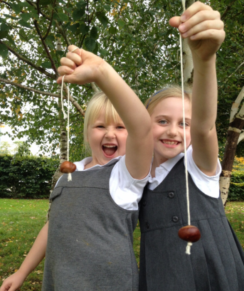
Child Protection/Safeguarding

Our ‘Child Protection Policy’ is reviewed annually, in line with the government Keeping Children Safe in Education document and our local safeguarding board. If you have any concerns about a child or member of staff, please contact our named safeguarding officer Alison Ighani.
We take the wellbeing of the children very seriously and ask that when you collect your child that you do not use your mobile phone on site. Thank you

Compliments & Complaints
We hope you will love High Flyers as much as the children do. We foster open and warm relationships with the children and parents and have become a club with a family feel.
If you have a complaint, please feel that you can discuss this with us at any time. We have a complaints policy and also a suggestion box for you to put forward your ideas.
Equally, if we have done something well, let us know so that we can ensure we do it again!
Compliments and complaints should be discussed in the first instance with the manager, who will be happy to listen and address any concerns.
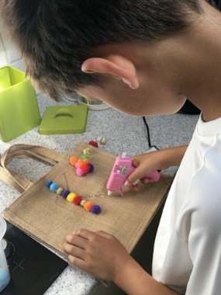

If you have any further questions, would like to come and look around or would like support with booking, please do not hesitate to ask us, in person, by phone or email.
Phone 07766 290242
email: highflyersclub@hotmail.co.uk
To book a place go to https://highflyersoxfordlimited.schoolipal.co.uk
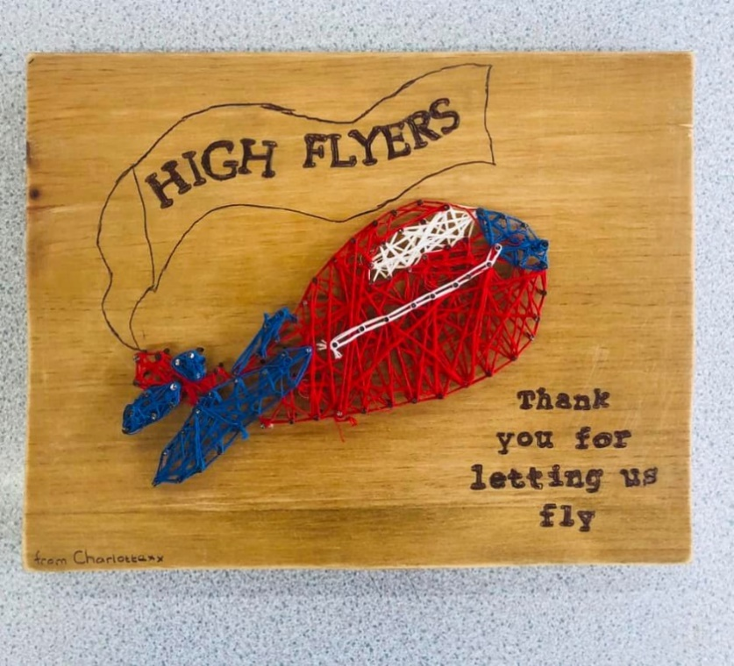
Made by one of our ‘High Flying’ children
We hope to see you very soon!

